Software Requirements Specification
- Introduction
This document describes the Software Requirements Specification (SRS) for the "IoT-based Laboratory Environment Monitoring and Control System" project.
- Problem Statement
- It is necessary to build a system capable of monitoring the environment in real-time and collecting data from multiple locations.
- The system must store data, display information on a Dashboard, and issue warnings when indicators exceed thresholds.
- The system needs the ability to automatically control devices or allow users to control them manually from the Dashboard.
- The system must be scalable to add more Nodes in the future.
- Scope
- Monitoring area and scope: An electronics laboratory.
- Area size: Approximately 60 m².
- System Architecture

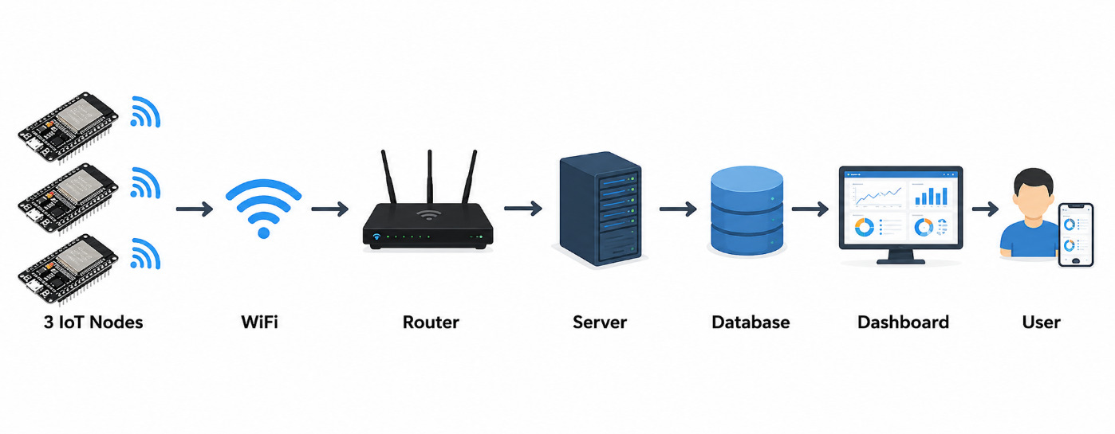
Overall Architecture (Data Flow): 3 IoT Nodes -> WiFi -> Router -> Server -> Database -> Dashboard -> User.
- Node 1: Placed at the room's entrance, used to monitor the environmental conditions at the front of the room.
- Node 2: Placed in the middle of the room, used to monitor general environmental conditions.
- Node 3: Placed in the equipment area, used to monitor environmental conditions affecting electronic devices.
- Hardware components of each Node: Includes an STM32F401RE microcontroller connected to an ESP8266, along with BMP280, BH1750, MQ135 components, Relays, LEDs, and a Buzzer.
Platform Technologies:
- Firmware: STM32CubeIDE, Arduino IDE.
- Communication: UART, WiFi, HTTP, or MQTT.
- Database: Firebase or MySQL.
- Backend: NodeJS or Firebase Functions.
- Frontend: HTML, CSS, JavaScript.
- Functions
Parameter monitoring functions:
- Measure temperature using the BMP280 sensor.
- Measure illuminance using the BH1750 sensor.
- Assess relative air pollution levels using the MQ135 sensor for early warning purposes.
Device control functions:
- Control ventilation fans, lighting, exhaust fans, and warning sirens via Relays.
Automatic control functions:
- After data is sent to the Server, the Server will check it against the configured thresholds.
- If the data exceeds the thresholds, the Server sends a command down to the Node for the Relay to control the device and simultaneously emit a warning signal.
Dashboard functions (User Interface):
- Supports Login and User Management.
- Displays the Node List and Real-time Dashboard.
- Provides Charts, and allows viewing of Data History and System Logs.
- Displays Warnings, and allows Relay Control and Threshold Setting.
- Non-Functional Requirements
- Non-Functional Requirements Warning threshold standards (Mandatory compliance): Thresholds must not be arbitrarily set but must be based on current standards and recommendations.
- Room temperature: Based on ASHRAE Standard 55, QCVN 26:2016/BYT (working conditions). Limits: 20-28°C (Normal), < 18°C or > 30°C (Warning).
- Illuminance (Lux): Based on TCVN 7114-1:2008 / ISO 8995-1 (Lighting of indoor work places). Limits: 500-750 Lux (Normal), < 300 Lux or > 1000 Lux (Warning).
- Air quality: Based on WHO Air Quality Guidelines, QCVN 05:2023/BTNMT.
- MQ135 sensor accuracy: Do not represent air quality measurement data as absolute accurate ppm values. The system must classify the status based on the calibration baseline into Normal (near baseline), Warning (30-50% above baseline), and Danger (> 50% above baseline).
- Development phase (Phase 2): The system must operate stably over WiFi, connect to the Server/Database, save history, and manage multiple Nodes simultaneously.
- General Use Cases
- UC1 - Account Management: The user logs into the Dashboard system.
- UC2 - Environment Monitoring: The user views the Real-time Dashboard, charts, history, and the list of online Nodes.
- UC3 - System Configuration: The user sets the standard thresholds for temperature, light, and air quality from the interface.
- UC4 - Manual Control: The user clicks buttons on the Dashboard to send Relay control commands (turn on/off fans, lights, sirens).
- UC5 - Warning Monitoring: The user views system warnings or system logs recorded when parameters exceed thresholds.
- UC6 - Automatic Monitoring (System): Collected data is sent to the Server, the Server checks the thresholds, and makes decisions to send Relay control commands completely automatically.
- Requirements List
- REQ-01 (Architecture): The system must maintain an architectural model with exactly 03 IoT Nodes.
- REQ-02 (Hardware): Each Node must be fully equipped with components: STM32F401RE, ESP8266, BMP280, BH1750, MQ135, Relays, LEDs, and a Buzzer.
- REQ-03 (MQ135 Indicator): Must process MQ135 data according to a relative pollution status classification method (Normal, Warning, Danger), and not record inaccurate ppm figures.
- REQ-04 (Standards): Must correctly apply ASHRAE, QCVN, TCVN, and WHO standards in setting the system's warning thresholds.
- REQ-05 (Control Flow): The Server system must have the capability to handle automatic logic: Receive data -> Check thresholds -> Send control command down to the Node -> Turn on/off peripheral devices via Relay -> Send warning.
- REQ-06 (Dashboard Phase 2): The Dashboard interface must contain all 9 modules: Login, Node List, Real-time Dashboard, Charts, History, Warnings, Relay Control, Threshold Setting, and System Logs.
- REQ-07 (Documentation): Do not arbitrarily change the number of Nodes, sensors, or set thresholds during the project development and documentation writing process.

